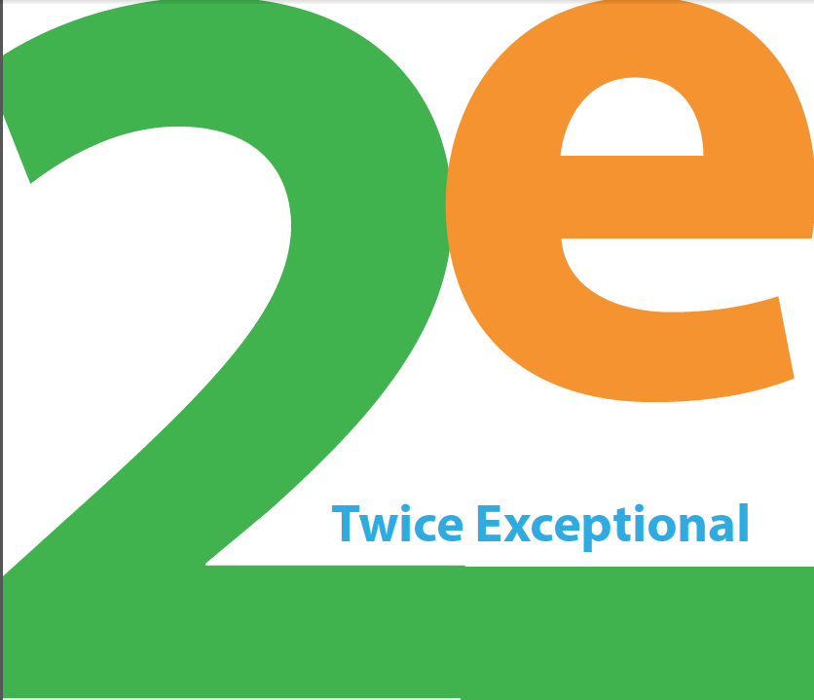

**When:** Sunday, September 17, 2017, 12:30 – 5:00 p.m.

**Where:** Northern Secondary School (Library downstairs)

**What:** Understanding Twice Exceptional Students: speakers include Carol Barnes, Australian National Coordinator of GLD (Gifted with Learning Disability) on being gifted with learning disability, Hayley Stinson, from Integra, on Executive Functioning and LD/ADHD, and Dr. Irena Valentin, of Blackstock and Valentin, on Anxiety.

**Who:** This conference is for parents, caretakers and teachers of 2e students.

**Tickets**: $10.75 in advance, $20 at the door. [**CLICK HERE TO BUY TICKETS**](https://www.eventbrite.ca/e/abc-twice-exceptional-mini-conference-tickets-37405640277)

The Association for Bright Children together with Northern Secondary School Council’s Gifted Advisory Committee and Learning Disabilities Committee are pleased to present a mini-conference on twice exceptional students.